IdeationPhase

Brainstorm&IdeaPrioritizationTemplate

Date | 19February 2026
TeamID | LTVIP2026TMIDs66458
ProjectName | GeminiHistoricalArtifactDescription
MaximumMarks | 4 Marks

Brainstorm&IdeaPrioritizationTemplate:
Brainstormingprovidesafreeandopenenvironmentthatencourageseveryonewithinateam to participate in the creative thinking process that leads to problem solving. Prioritizing volumeovervalue,out-of-the-boxideasarewelcomeandbuiltupon,andallparticipantsare encouraged to collaborate, helping each other develop a rich amount of creative solutions.
Use this template in your own brainstorming sessions so your team can unleash their imagination and start shaping concepts even if you're not sitting in the same room.

Step-1:TeamGathering,CollaborationandSelecttheProblemStatement

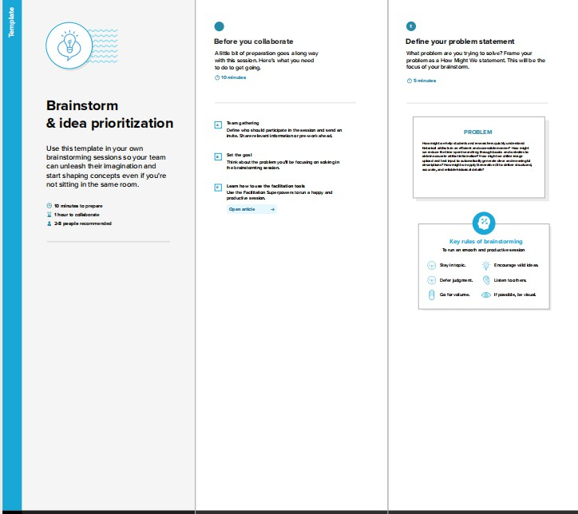

Step-2:Brainstorm,IdeaListingandGrouping
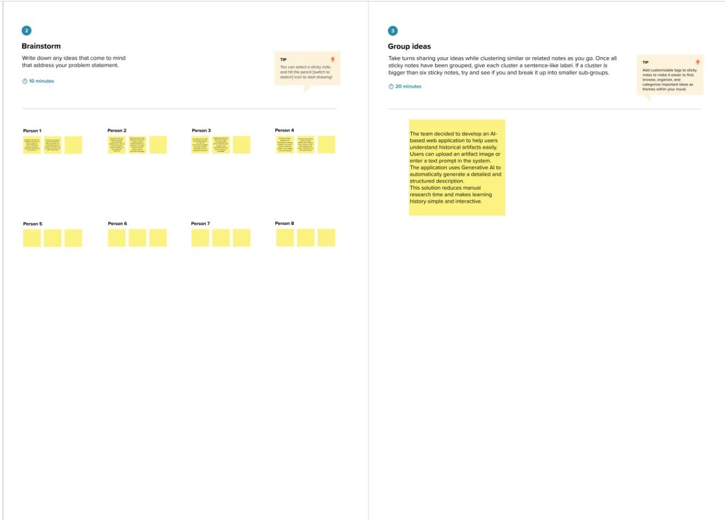

Step-3:IdeaPrioritization
